Forecast Salary Growth and Cost of Living - Full Answer
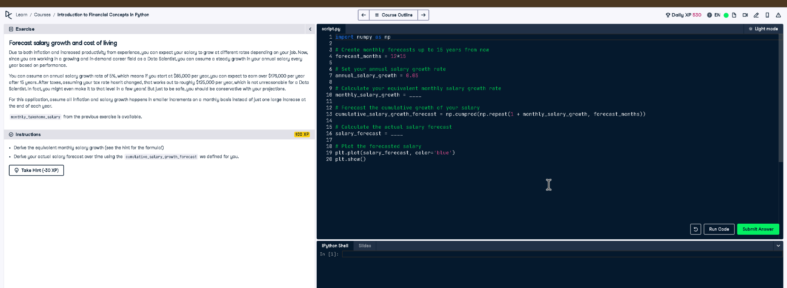

Full Code Answer:
import numpy as np
# Create monthly forecasts up to 15 years from now
forecast_months = 12 * 15
# Set your annual salary growth rate
annual_salary_growth = 0.05
# Calculate your equivalent monthly salary growth rate
monthly_salary_growth = (1 + annual_salary_growth)**(1/12) - 1
# Forecast the cumulative growth of your salary
cumulative_salary_growth_forecast = np.cumprod(np.repeat(1 + monthly_salary_growth, forecast_months))
# Calculate the actual salary forecast
salary_forecast = monthly_takehome_salary * cumulative_salary_growth_forecast
# Plot the forecasted salary
plt.plot(salary_forecast, color='blue')
plt.show()

Question:
How can you forecast monthly salary growth over 15 years using an annual growth rate of 5%?

20-word Explanation (Question):
Annual salary growth must be converted into monthly increments to accurately project salaries over multiple years with compounding growth.

Answer:
Convert annual growth to monthly via (1 + annual)^(1/12) - 1, then apply cumulative np.cumprod for salary.

20-word Explanation (Answer):
Using np.cumprod on the monthly growth factor generates a cumulative forecast, scaled by current salary to predict future earnings.

